Name : Mahardhika Bathiarto Dim Zarita

Class : X

NIM :L200184134

**Practice 1**

1. Make a circuit of image and edit the everything properties of component as showed of table.

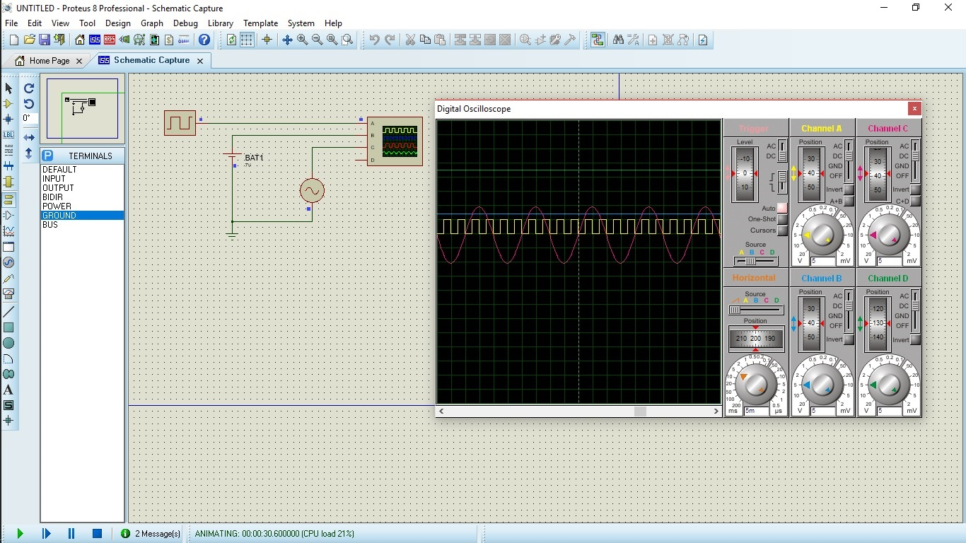

Table 1. component of circuit

|  |  |  |
| --- | --- | --- |
| No | Device | Information |
| 1 | Alternator | V = 5 Volt, f = 100 Hz |
| 2 | Cell | V = 5 Volt |
| 3 | Clock | F = 100 Hz |
| 4 | Ground | Pick from Terminals |
| 5 | Osiloskop | Pick from Instrument |

1. The simulation will show to us a signal line from batre,clock and alternator.

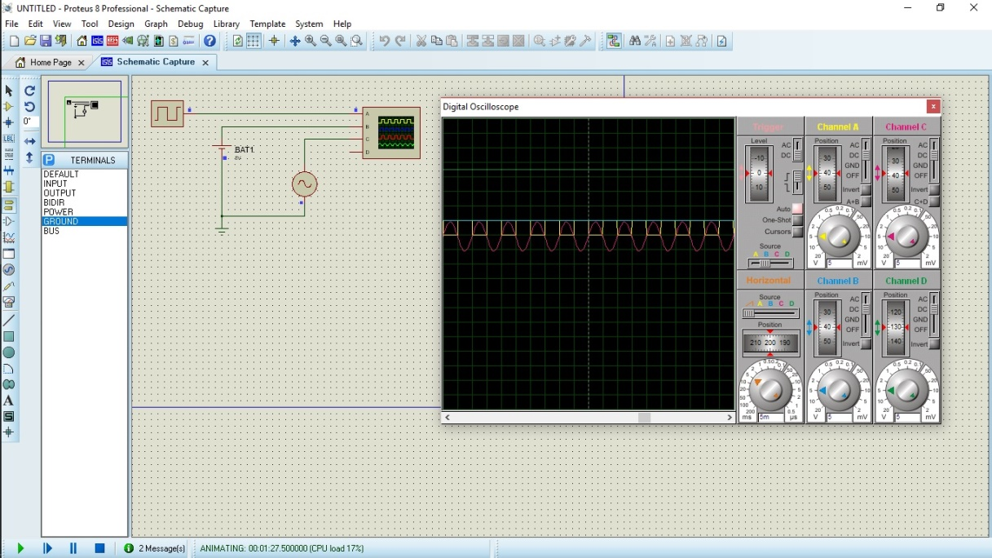

And explain it !

🡪Channel A is ***clock,*** the shapeof channel A is square.it is analog signal. Channel B is  ***Cell,*** the shape of channel B is line,it is digital signal. Channel C is Alternator,the shape of channel C is warped,it is analog signal. The channel D is nothing.

1. Turn off that simulation ! then edit your component as table 2.

Table 2. Propertiese component

|  |  |  |
| --- | --- | --- |
| No | Device | Information |
| 1 | Alternator | V = 10 Volt, f = 50 Hz |
| 2 | Cell | V = 7 Volt |
| 3 | Clock | F = 200 Hz |

1. Run the simulation !

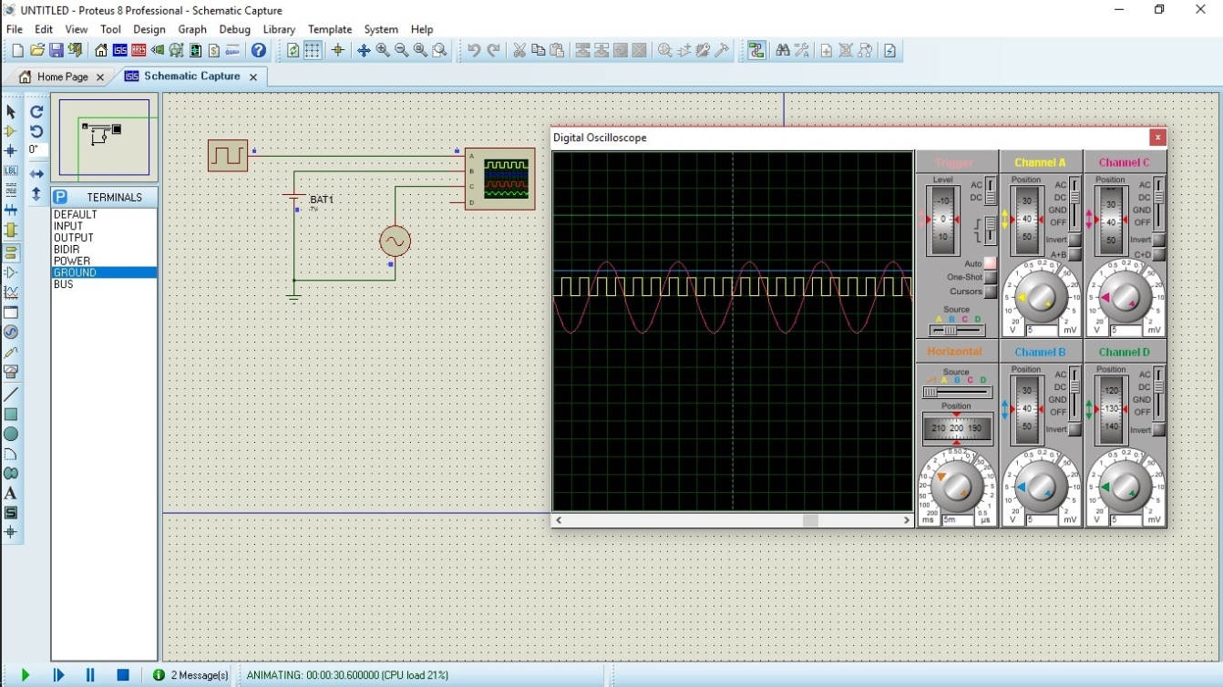

And explain it !

🡪Trigger on source B, Channel A is square,the length of A is 1,5. Channel B is line, channel C is warped,it is so big size.

1. Answer The Questions !
2. What is the different between analog signal and digital !

The shape for analog is line, and digital is square/warped

1. How about the signal characteristic of every component !
2. Signal by Alternator :

🡪Analog, warped shape

1. Signal by Batery :

🡪Analog, line shape

1. Signal by clock source :

🡪Digital, square shape

1. Make the conclusion from your observation of kind exercise of signal.

🡪If the shape is square, it is digital.if the shape is line and warped,it is analog

signal.

**Practice 2**

1. Make a circuit Proteus 8 simulation on this image.

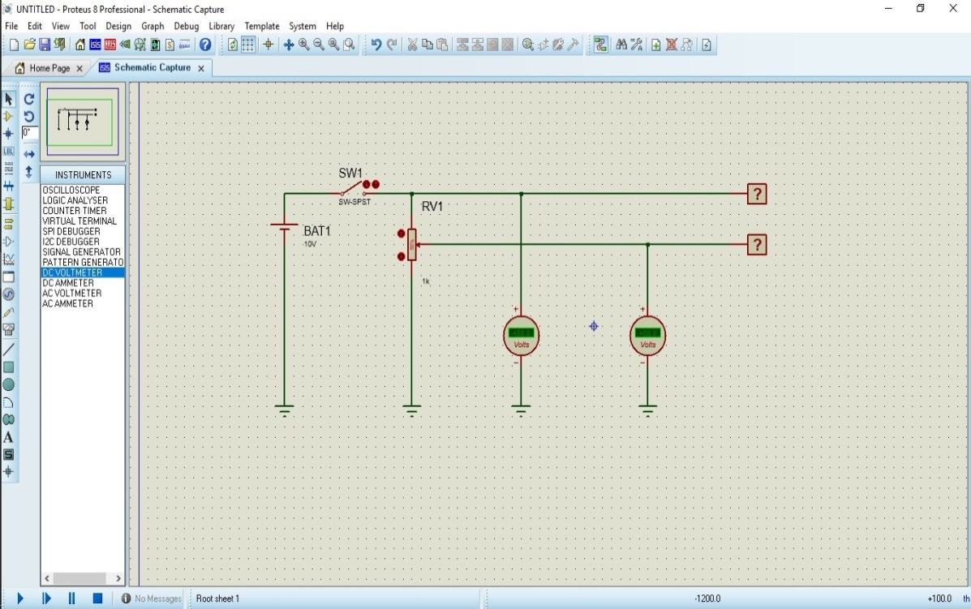

Table 3.component for circuit.

|  |  |  |
| --- | --- | --- |
| No | Device | Information |
| 1 | Cell | Edit to 10 volt |
| 2 | SW-SPT |  |
| 3 | POT-HG |  |
| 4 | Logicprobe |  |
| 5 | Ground | Pick from Terminals |
| 6 | DC Voltmeter | Pick from Instrument |

1. Run that simulation as image!

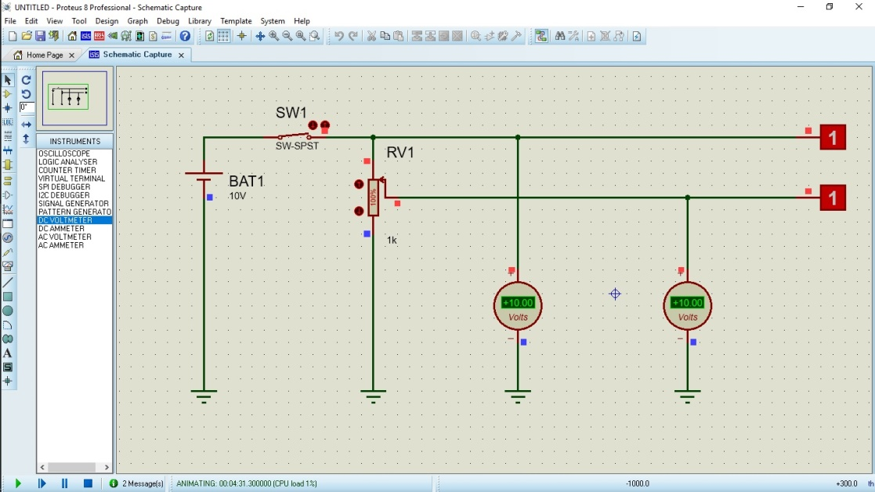

1. Click SW1 ! in your simulation, answer the question !
2. Voltmeter DC 1 : +10.00 Volt
3. Voltmeter DC 2 : +5.00 Volt
4. Logicprobe 1 show logic condition : 1
5. Logicprobe 2 show logic condition : 1
6. Click RV1 component (Resistor Variabel/POT-HG) up and down ! and then answer the question !
7. Logicprobe 2 show logic condition 1(**HIGH**)

If Voltmeter DC 2 : +5.00 Volts until +10.00 Volts

1. Logicprobe 2 menunjukan kondisi logika 0 (Low)

If Voltmeter DC 2 : +3.00 Volts until +3.60 Volts

1. Make a conclusion based of your analys in range signal digital exercise !

* If voltmeter DC 1 is high until +10.00,the value of logicprobe is 1. And if the Voltmeter is low until +3.00 until +3.60 the value of logicprobe is 0.